Professor Cigdem Eskicioglu, University of British Columbia, Canada
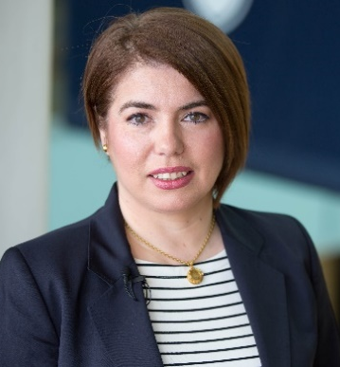
Cigdem Eskicioglu is a Professor and Natural Sciences and Engineering Research Council of Canada (NSERC) /Metro Vancouver Senior Industrial Research Chair in Advanced Resource Recovery from Wastewater in the School of Engineering at University of British Columbia (UBC)’s Okanagan Campus in Canada. She is internationally recognized for her research in developing new bioreactor technologies for maximizing energy (i.e., biomethane and biohydrogen) and for resource recovery from organic waste, particularly wastewater sludge.
Over the last 14 years, Dr. Eskicioglu has attracted more than $13M in research funding and has founded/led the Bioreactor Technology Group (BTG) at (UBC)’s Okanagan Campus. The group has been operating four state-of the-art facilities (i.e., Advanced Anaerobic Digestion, Thermo-chemical Biomass Processing, Particle Sizing/Imaging and Trace Contaminant Detection). As a result of BTG’s unique infrastructure/expertise, the group has developed partnerships with many wastewater utilities, industries, and government agencies for sustainable waste disposal.
Dr. Eskicioglu has established a strong publication record (over 120 peer-reviewed articles, Google Scholar Citation: 4800, h-index: 36) in the most prestigious journals, conferences and has 1 patent in the field. Dr. Eskicioglu has been recognized by the 2020 UBC Okanagan Researcher of the Year Award (Engineering and Science category), the UBC School of Engineering’s Outstanding Researcher Award (2017), the Confederation of University Faculty Association’s 2012 BC Early in Career Award, and by City of Kelowna's 2011 Mayor’s Environmental Award. She has also served as scientific committee or panel member for many national/international grant agencies and conferences. Additionally, she is a sought-after consultant for Canadian and international firms, water utilities and non-profit organizations.

