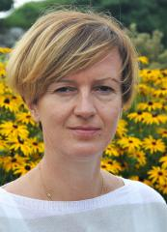
Magdalena Zielińska works as an associate professor in the Department of Environmental Biotechnology, Faculty of Geoengineering, University of Warmia and Mazury in Olsztyn, Poland. Her research interests include issues related to removal of nutrients and selected organic micropollutants from wastewater (aerobic and anaerobic processes, membrane technologies), water treatment, sewage sludge processing and valorization of wastewater and waste. To date, she has co-authored about 120 peer-reviewed journal articles and chapters in monographs, and co-authored a book "Bisphenol A removal from water and wastewater", which was published by Springer International Publishing in 2019. Magdalena Zielińska was the principal investigator in 4 research projects funded by the National Science Centre. The research in one of these projects was recognized by nominating Magdalena Zielińska for the Polish Intelligent Development Award in 2020 in the category "Scientist of the Future". Magdalena Zielińska has also been involved as the investigator in 12 national/international research projects, including Horizon 2020.

