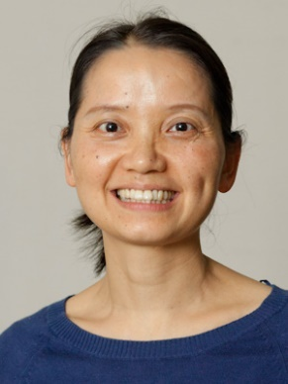

Zhongfang Lei received her bachelor’s, master’s, and doctorate degrees from Tongji University, China. She is currently working as an Associate Professor in the Faculty of Life and Environmental Sciences, University of Tsukuba, Japan. Dr. Lei’s research covers the development and design of efficient processes for water/wastewater and organic solid waste treatment, especially nutrients and resources recovery via bacterial and algal-bacterial granular sludge technique, in addition to reclamation, reuse and recycling of waste biomass. Up to the present, as the PI Dr. Lei completed more than 20 projects from national/joint international scientific research funds, and she authored/co-authored more than 250 peer-reviewed journal papers relating to waste conversion and wastewater treatment. Dr. Lei serves as an editor of Bioresource Technology Reports and an editorial board member of Bioresource Technology and Journal of Water Process Engineering.

