Wenshan GUO

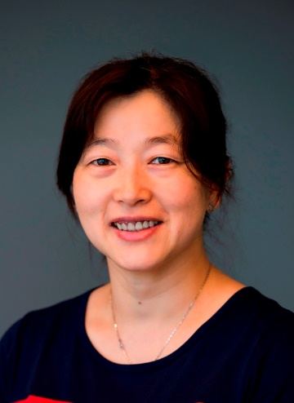

150-word Biography
Dr. Wenshan Guo is a Professor in School of Civil and Environmental Engineering, University of Technology Sydney. Her current research focuses on innovative wastewater treatment and reuse technologies, green technologies for resource and energy recovery, water-waste-energy nexus and climate change mitigation. She has authored 5 books, 46 book chapters and >430 journal articles, and is an Editor, Bioresource Technology Report (Elsevier), Associate Editor, Journal of Water Process Engineering (Elsevier), Associate Editor, Journal of Hazardous, Toxic & Radioactive Waste (ASCE), and Academic Editor, Journal of Chemistry (Hindawi, USA). She has been recognized as 2021 Highly Cited Researcher in both Biology and Biochemistry Category and Environment and Ecology Category, as well as 2019 and 2020 Highly Cited Researcher in Cross Field Category by Clarivate Analytics, Web of Science Group. She has also been named as one of the Top 40 Research Superstars in Australia (2020 and 2021, Environmental Science).

