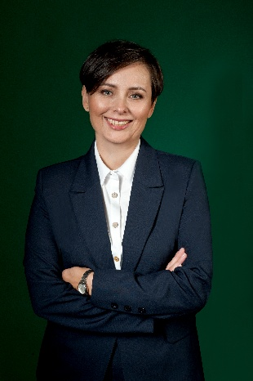
Małgorzata Wilk, h-index = 26 (according to Web of Science)
Associate Professor
Head of Department of Heat Engineering & Environment Protection
Faculty of Metal Engineering and Industrial Computer Science
AGH University of Krakow, Poland

mwilk@agh.edu.pl; (+48) 510 026 066
ORCID: 0000-0001-6068-721X
Web of Science ResearcherID: S-3511-2017
Scopus: 36703661900

Short CV
Małgorzata Wilk graduated in chemical engineering in 1997, her PhD was successfully defended in thermal engineering in 2007 and dedicated the habilitation to pretreatment processes and solid biofuels in the energy discipline in 2018. She works as an associate professor at AGH University of Krakow since 2019 in the field of engineering and technology and in the discipline of environmental engineering, mining and energy. She is a recognized researcher in thermal pretreatment processes mainly torrefaction, pyrolysis and hydrothermal carbonization. She is also interested in combustion processes of alternative fuels (e.g. biomass, sewage sludge and organic waste), specialising in solid biofuel characteristics, waste management and environmental protection. Her research activities are granted by few scientific national awards. She is an author and co-author of more than 180 publications and peer reviewed conference papers including 58 publications in high impact journals and holds 5 patents, including the patent for hydrothermal carbonization of organic wastes. She was listed in the World Ranking of Top 2% Scientists from 2022 to 2025 published by the Stanford University and Elsevier. She is a principal investigator and co-investigator in the projects nationally and internationally recognized such as National Science Centre Poland or Era-Net Water projects. She is a member of Combustion Institute and Hydrochar Network.

