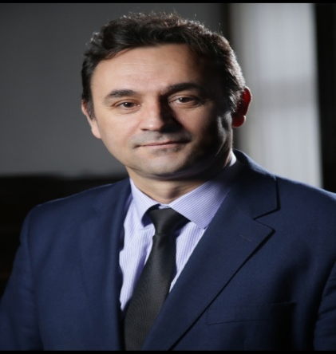
Dr. Hysen Bytyqi is a distinguished professor at the University of Prishtina, Faculty of Agriculture and Veterinary Sciences, in Kosovo. He earned his PhD through a joint program with the Norwegian University of Life Sciences and the University of Prishtina, reflecting strong international academic collaboration. His expertise spans animal science, genetic resource conservation, sustainable food production, food waste reduction, and environmental impact assessment. Throughout his career, Dr. Bytyqi has completed numerous professional specializations across Europe and the United States, enhancing his research and leadership capacities. He has coordinated more than 30 national and international scientific projects and authored an extensive body of work, including over 40 peer-reviewed articles, conference papers, books, and specialized atlases. He has served as Advisor to Kosovo's Ministers of Education and Ministry of Agriculture, Vice-Rector of the University of Prishtina, and Director of its Academic Development Office. He led the university’s Research Strategy and contributed to Kosovo’s National Research Program. He has been Kosovo’s National Contact Point for Horizon 2020 in food security. In 2022, he became a member of the Kosovo National Science Council.

